

**DIGITAL FORENSICS (GIT PLUS LIMITED)**

**BY**

**GROUP 4**

**MEMBERS**

**ABDULLAHI RIDWAT AYOTOMIWA- ADS19A00133Y**

1. **Outline a vivid and comprehensive list of problems that confronts the current state of any selected establishment of your own and suggest solutions for each of them.**

**GIT PLUS LIMITED**

GIT Plus is an established IT company committed to providing innovative and cost-efficient IT services with advanced state-of-the-art technologies. They understudy their clients to offer them fit-for-purpose and appropriate technological solutions. To give their clients the best service and support, GIT Plus combines the dedication and expertise of their in-house team with the support of their international partners, and cutting-edge solutions from major international equipment manufacturers and suppliers.

Based on observation and data gathered, below are some problems faced by the selected establishment **(GIT PLUS LIMITED)**:

* **Various pieces of their hardware and software have problems:** GIT Plus Limited personnel routinely experience incorrect warnings, sluggish internet, and generally poor performance on essential devices needed to do tasks. The bottom line of the company and employee productivity might both be severely harmed by this.

This issue may be resolved by either establishing a company-wide helpdesk or outsourcing the IT to a reputable managed service provider providing round-the-clock support.

* **Insufficient knowledge of cloud management:** There are misunderstandings because GIT Plus Limited's staff or cloud management specialist does not fully comprehend how the cloud functions (and how it may be effectively used to improve business performance).

In order to address this issue, GIT Plus should make sure that a qualified professional is tasked with administering the cloud and utilizing it to store, access, and safeguard data.

* **Old technologies and infrastructure:** At GIT Plus Limited, certain important departments, such as the development department, continue to employ antiquated infrastructure and technology, which lowers productivity.

GIT Plus Limited should make sure that the necessary and employed infrastructures are up to date in order to reduce or eliminate this problem.

**QUESTION 2**

1. **Identify the technological growth in digital forensics with respect to your chosen establishment**

* **High rate of flexibility:** GIT Plus Limited has developed top-notch solutions and made advances using the majority of recent technologies. As a result of innovations, company operations might become more flexible. One of the technologies that have had the most impact on how people do business both locally and online is cloud computing. They frequently find it helpful for performance management and documentation since GIT Plus uses this cloud computing technology. Through the new technical platforms, they gain flexibility and efficiency while investing less money in the process.
* **The ability to outperform competitors:** GIT Plus has been able to keep a competitive advantage over its competitors ever since it began using various technologies. They employ a first-movers strategy along with the required technologies to develop new products, differentiate those products from those already on the market, and improve customer service. They also devise ways to cut costs through increased productivity and a decreased need for employee overhead.
* **Customer service:** At GIT Plus, the customer service department now makes use of some automation technologies or tools like chatbots and automated [text message marketing solutions](https://www.businessnewsdaily.com/15044-best-text-message-marketing-solutions.html). These consumer-facing tools automate typical customer service interactions by answering common enquiries immediately. They only refer customers to a representative when the chatbot is insufficient for handling their needs.

**QUESTION 3**

1. **Discuss the simulation system software development that you would adopt for this project and justify your choice**

For this project, MATLAB would be the simulation system software development that was chosen. In order to complete this project successfully, the simulation system would be used.

The most well-known tool with all of its toolboxes is the MATLAB system. When necessary, the derivative vector can be evaluated using the Ordinary Differential Equation solvers that are included into the MATLAB environment. Given that the derivative vector, the model description, follows standard programming conventions.

We will be making use of MATLAB, in python to perform the simulation. In order to make use of MATLAB in python, we imported a library called Matplotlib. Matplotlib is a visualization library that combines other libraries to create visual representations of data. It provides a MATLAB-like interface with its Pyplot module.

**QUESTION 4**

1. **Create and simulate all the possible ideas concerning your data**

Based on the data we gathered concerning the consultation request process of the establishment (GIT PLUS LIMITED), we conducted an analysis or simulation analysis on the consultation request process, because of some setbacks we observed.

The consultation request process at GIT Plus has two procedures, which one of them is through their website and the other is through their social media platform.

The utilization of these procedures needs to be assessed. In addition, the following modification to the original system is of interest: the frequency of arrival of both parts is exponential with the same respective means as in the original system.

The objective is to obtain the utilization of these procedures for the original system and the modification in a meaningful pattern.

The website consultation request procedure arrives every 10 minutes, and the social media platform arrives every 2 minutes. It takes 20 minutes to route a website procedure and 5 minutes to route a social media procedure to the person in charge of consultation request. Customers have to wait in a queue till the consultation attendant becomes available or finish responding to another customer.

For the simulation, we made use python (which is a programming language) and also python library called matplotlib. Matplotlib is a visualization library that combines other libraries to create visual representations of data. It provides a MATLAB-like interface with its Pyplot module.

Below is a visual or graphical representation of the analysis or simulation we did.

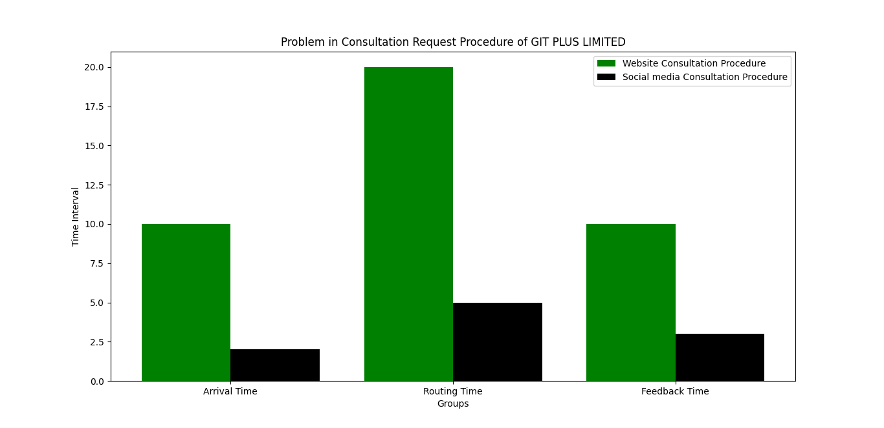

From the above representation, we can see that the color represents the website procedure and the black color represent the social media procedure. Based on the data we gathered and the analysis we did, we can clearly see from the above graphical representation that,

* When a request is made via the website, it takes a long time, specifically, 10 minutes, for the request to get to the employee in charge of the consultation requests. If a request is done via the company’s social media platform, the message arrives quickly, compared to the website procedure.
* And, connecting or routing the customer to a consultation agent via the website procedure, takes a whole lot of time compared to the social media platform.
* And finally, when a customer makes use of the website to request for consultation, it takes time for the use to get feedback, compared to the social media procedure.

**QUESTION 5**

1. **Design and verify some pilot run to validate the designed model and to determine other needed conditions for simulation runs**

There are two essential processes in achieving that, and they are the **validation** and **verification** methods. These steps serve to validate the created model and define other necessary conditions for simulation runs.

The validation procedure consists of comparing two findings to each other. A comparison is referred to be true when it is valid, and false when it is invalid. Comparing an operational system to a conceptual model in the real world might be done by checking both the proposed or initial model and the operating system (using a statistical or hypothesis testing process). Comparing the final simulation result with analytical findings, recording intermediate results and comparing them with observable outcomes, and testing the simulation model output using a variety of input combinations are a few methods that may be used to assess the design model.

In the verification process, the consistency of two or more results is examined. A comparison is done to assess how accurate the results are. It would be helpful to compare the conceptual descriptions and requirements with the implementation models, their data, and related models. Examining a model's validity, determining a simulation model's representative output, and testing a model utilizing assumptions data are some things to be on the lookout for while validating a model.

These two fundamental stages enable us to evaluate the developed model effectively and economically while also identifying additional prerequisites for simulation runs.

**QUESTION 6**

1. **Design reports that should be generated from the digital forensic with respect to your chosen establishment.**

GIT Plus is an established IT company committed to providing innovative and cost-efficient IT services with advanced state-of-the-art technologies. Due to the poor maintenance and absence of updates and other challenges mentioned earlier, there are numerous vulnerabilities and issues that the established encounters.

In order to aid the firm in understanding the issue, this study aims to present both a business-wide security strategy and a computer forensics investigation plan.

The GIT Plus Limited issues were investigated utilizing a digital forensics approach, which was advantageous for the company in many ways.

Based on our findings, we pointed out some problems faced by the establishment (GIT Plus Limited). And they are as follows:

* **Various pieces of their hardware and software have problems:** GIT Plus Limited personnel routinely experience incorrect warnings, sluggish internet, and generally poor performance on essential devices needed to do tasks. The bottom line of the company and employee productivity might both be severely harmed by this.
* **Insufficient knowledge of cloud management:** There are misunderstandings because GIT Plus Limited's staff or cloud management specialist does not fully comprehend how the cloud functions (and how it may be effectively used to improve business performance).
* **Old technologies and infrastructure:** At GIT Plus Limited, certain important departments, such as the development department, continue to employ antiquated infrastructure and technology, which lowers productivity.
* **Consultation request procedure:** this problem is one of the major problems that GIT Plus faces, which has led to the loss of customers and a decrease in productivity. The consultation request process at GIT Plus has two procedures, one is through their website and the other is through their social media platform. And based on the analysis we conducted, we concluded that the two procedures are not that efficient, most especially, the website procedure, which has resulted in a lot of complaints from the customers.
* And finally, because they often juggle, developers at GIT Plus Limited encounter more problems than they anticipated. The majority of people in the firm find it challenging to focus on a single job or module as a result of having too many tasks assigned to one person and lacking multitasking skills.

Although this problem has resulted in a lot of setbacks at GIT Plus, the study we carried, out and based on the data we gathered and analyzed, we came up with some recommendations or possible solutions, that the organization should implement, in order to eliminate this problem. And these recommendations are as follows:

* Recruiting or employing more consultation request attendants
* Implementing or making use of the chatbot technology in their website, in order to increase efficiency and reduce delays in arrival, feedback and the routing time

In conclusion, we have been able to conduct an analysis, simulate the data that has been collected, and also come up with solutions to eliminate the problem. With the two recommended solutions carried out appropriately by GIT Plus, it will increase their productivity and their customer service performance.

**QUESTION 7**

**7 Discuss the testing strategies/techniques that you would use on this project; and provide a table of test criteria and corresponding test data for the testing**

A strategy for software testing integrates software test case design approaches into a well cwell-considereds of phases in order to successfully build software or an idea. A testing road map is provided by software testing strategies.

**Acceptance testing** alongside with **automated testing (also known as dynamic testing)**, which focuses on the behavior of a product, software, an idea or an organization or establishment are the suggested or chosen technique for this project.

Testing for accuracy, performance, reliability, and security are the four categories under which automated testing is categorized.

User acceptability testing, also known as acceptance testing, is a type of testing carried out to determine whether the concept or product is created or implemented in line with the standards and defined criteria and fulfills all the needs supplied by the customer or business. There are several names for acceptance testing, including validation testing, final testing, QA testing, factory acceptance testing, and application testing. Additionally, acceptance testing may be carried out at two different levels: one at the level of the supplier of the system or concept, and another at the level of the final user.

**Below is the test criteria and the corresponding data:**

|  |  |
| --- | --- |
| **TEST CRITERIA** | **TEST DATA** |
| Customer service criteria | Customer Service Department at GIT Plus Limited |
| Time management criteria | Development and information gathering processes at GIT Plus Limited |
| Consultation request criteria | Arrival time, routing time and feedback time for consultation request procedures at GIT Plus Limited |